With the support of the Jean Monnet programme of the European Union (Information and Research Activity
‘Toward a More Resilient European Neighbourhood: Security Cooperation and the Management of Current and Future Threats in Europe’s Strategic Orbit’)

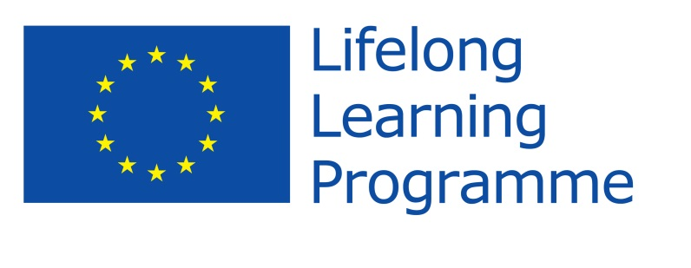

PROGRAMME

May 15, 2014
16.00-18.00 Opening ceremony, Welcome note

Project directors: Stefan Wolff, Tetyana Malyarenko; Michael Gaul, Senior Advisor for Strategy and Projects in NATO’s Emerging Security Challenges Division; Representative of the European Delegation to Ukraine

May 16, 2014
10.00.-11.30. Lecture ‘A Strategy for NATO, the EU in the New Europe’
Dr. Derek Averre, University of Birmingham, UK
11.30.-12.00. Coffee-break
12.00.-13.15. Lecture ‘The EU as a Strategic Actor within NATO and Beyond’
Dr. Derek Averre, University of Birmingham, UK
13.15.-15.00. Lunch
15.00.-16.15. ‘Capabilities and Capacities in Context: NATO Evolving Role in the Wider Region’
Dr. Alistair Shepherd, Aberystwyth University, UK
16.15.-16.45. Coffee-break
17.00 + Introduction to simulation game: background and emerging cyber/CBRN risk assessments
Prof. Chad Briggs, Johns Hopkins University, USA
20.00 Welcome dinner

17 May, 2014
9.00.-10.15.

Lecture ‘The European Security Continuum and the EU as an International Security Provider’
Dr. Alistair Shepherd, Aberystwyth University, UK
10.15.-11.30.
Interactive Presentation:
‘Minorities at Risk: a Risk Assessment Model of Ethno-political Conflict’
Prof. Stefan Wolff, University of Birmingham, UK
11.30.-12.00. Coffee-break
12.00.-13.15.
Roundtable discussion ‘How Can We Narrow the Gap between Early Knowledge, Warning and Action?’ Chair: Prof. Stefan Wolff; participating faculty: Prof. Chad Briggs, Dr. Alistair Shepherd, Dr. Derek Averre
13.15.-15.00. Lunch
15.00.-19.00+ Simulation/Wargame ‘Complex Instability Early Warning and Response’
Prof. Chad Briggs, Johns Hopkins University, USA
20.00 Dinner
May 18, 2014
9.00.-10.15.
Simulation: conclusion and discussion ‘Post-Wargame Hotwash and Debriefing: Lessons for NATO Partner Countries’
Prof. Chad Briggs, Johns Hopkins University, USA and Prof. David Galbreath, University of Bath, UK
10.15.-11.30. ‘The End of an Era? Strategic Analysis in Contemporary Europe’
Prof. David Galbreath, University of Bath, UK
11.30.-12.00. Coffee-break
12.00.-13.15. Lecture ‘The EU’s Neighbourhood Policy and the Challenges of the Eastern Partnership’ Prof. Richard Whitman, University of Kent
13.15.-15.00. Lunch
15.00.-16.30. Case study (small group exercise) ‘Bosnia and Herzegovina: A Greater Threat Inside or Outside NATO and the EU?’
Dr. Annemarie Peen Rodt, Roskilde University, Denmark
16.30.-17.00. Coffee-break
17.00.-18.30. Case study (small group exercise) ‘The Armed Conflict in the Republic of Macedonia in 2001: from the Escalation of Albanian-Macedonian Conflict to Signing the Ohrid Framework Agreement’ Dr. Annemarie Peen Rodt, Roskilde University, Denmark
20.00 Dinner

May 19, 2014

9.00-10.15
Conflict Prevention and Early Warning in the Practice
Interactive presentation ‘Fragile States and Dilemmas of Statebuilding’
Prof. Ulrich Schneckener, Osnabrueck University, Germany

10.15-11.30

Lecture followed by discussion ‘The Role of Armed Non-State Actors in Fragile States’
Prof. Ulrich Schneckener, Osnabrueck University, Germany

11.30-12.00 Coffee-break
12.00.-13.15. Lecture ‘The Crimea Crisis of 2014: The EU’s Georgia Moment of 2008 Revisited’
Prof. Richard Whitman, University of Kent
13.15-15.00 Lunch

15.00-16.30 Case study (small group exercise) ‘Mass Protests and Revolutions in Weak and Failing States’ Prof. Tetyana Malyarenko, DonSUM, Ukraine
16.30-17.00 Coffee-break
17.00-18.30 Roundtable on Ukraine
Chair: Prof. Ulrich Schneckener, Osnabrueck University, Germany; participating faculty: Prof. Stefan Wolff, Prof. Tetyana Malyarenko, Prof. Richard Whitman, Prof. David Galbreath
20.00. Dinner

May 20, 2014

9.30-11.00. Case study (small group exercise) ‘Managing a Local Conflict in a Complex Regional Environment’ Prof. Stefan Wolff, University of Birmingham, UK
11.00-11.30 Coffee-break
11.30-13.00. Lecture ‘The Caucasus Region: Current Realities’

Lawrence Scott Sheets, South Caucasus Project Director, International Crisis Group
13.00-15.00 Lunch

15.00-16.30. Case study (small group exercise) ‘The Geneva Talks: The Dynamics Behind a Half Decade of Virtual Deadlock’ Lawrence Scott Sheets, South Caucasus Project Director, International Crisis Group

16.30-17.00 Coffee-break

17.00-18.15

Case study (small group exercise) ‘The Russian North Caucasus: Understanding Challenges for Regional and European Security’ Lawrence Scott Sheets, South Caucasus Project Director, International Crisis Group

20.00 Dinner

May 21, 2014
9.00-10.15
Concluding Roundtable Discussion ‘A Synergy of Internal Strategic Analytical Capabilities of the NATO Member States and Partner Countries’
Chair: Prof. Stefan Wolff, University of Birmingham, UK, Prof. David Galbreath, University of Bath, UK, Prof. Tetyana Malyarenko, DonSUM
10.15-11.30 Presentation of joint publication project
Project directors: Prof. Stefan Wolff, University of Birmingham, UK,
Prof. Tetyana Malyarenko, DonSUM, Ukraine
11.30-12.00 Coffee-break
12.00-13.00 Discussion of the project results and closing ceremony
13.00 Lunch and departure of participants

